 Master in Artificial Intelligence (UPC-URV-UB)

Master’s Thesis proposal

General Information

Master’s Thesis Title: | Head Pose Detection in Uncontrolled Environments
Orientation: | professional  research
M.Sc. Th. Advisor’s Dept.  & University: | MAIA,UB
M.Sc. Th. Advisor: | Sergio Escalera and Petia Radeva
M.Sc. Th. Advisor e-mail: | Sergio@maia.ub.es
Observations:

M.Sc. Thesis Description

Main issues / Brief Description:

Detailed Description:

The master thesis is focused on a Computer Vision and Pattern Recognition problem. Head pose detection is a challenging task because of the high distortions in face appearance. In this Thesis, we describe face regions so that they can be detected in uncontrolled environments using probabilistic methods that learn face constraints. This system will be applied to real applications in order to detect boring/motivation states of subjects that interact in video sequences.
Other comments:

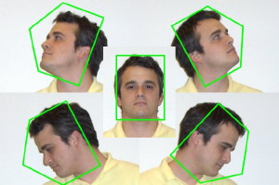

Barcelona, December 16th 2008

